**MODULE 3 : Python Assignment**

**1.Consider a list (list=[]).You can perform the following commands**

* **insert i e: Insert integer at position.**
* **print: Print the list.**
* **remove e: Delete the first occurrence of integer**
* **append e: Insert integer at the end of the list.**
* **sort: Sort the list.**
* **pop: Pop the last element from the list.**
* **reverse: Reverse the list.**

list = [];

list.insert(0,1)

list.insert(1,2)

list.insert(2,3)

list.insert(3,10)

list.insert(4,6)

print(list)

list.remove(1)

print("After deleting first occurance of list :")

print(list)

list.append(0)

print("After inserting integer at the end of the list :")

print(list)

list.sort()

print("After Sort :")

print(list)

list.pop()

print("After popping the last element from the list :")

print(list)

list.reverse()

print("After reversing the list :")

print(list)

**OUTPUT** 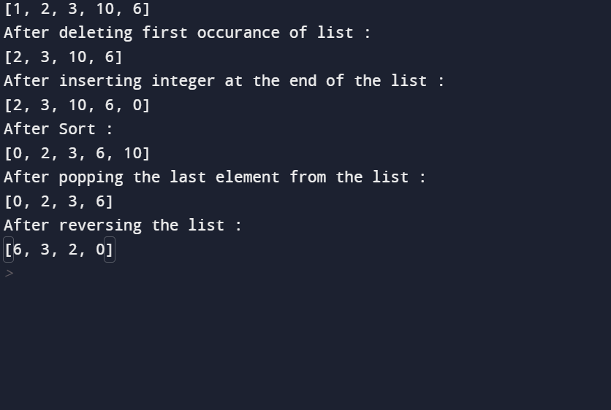

**2.Write a calculator program in python?**

# This function adds two numbers

def add(x, y):

return x + y

# This function subtracts two numbers

def subtract(x, y):

return x - y

# This function multiplies two numbers

def multiply(x, y):

return x * y

# This function divides two numbers

def divide(x, y):

return x / y

print("Select operation.")

print("1.Add")

print("2.Subtract")

print("3.Multiply")

print("4.Divide")

while True:

# take input from the user

choice = input("Enter choice(1/2/3/4): ")

# check if choice is one of the four options

if choice in ('1', '2', '3', '4'):

num1 = float(input("Enter first number: "))

num2 = float(input("Enter second number: "))

if choice == '1':

print(num1, "+", num2, "=", add(num1, num2))

elif choice == '2':

print(num1, "-", num2, "=", subtract(num1, num2))

elif choice == '3':

print(num1, "*", num2, "=", multiply(num1, num2))

elif choice == '4':

print(num1, "/", num2, "=", divide(num1, num2))

next_calculation = input("Let's do next calculation? (yes/no): ")

if next_calculation == "no":

break

else:

print("Invalid Input")

**OUTPUT**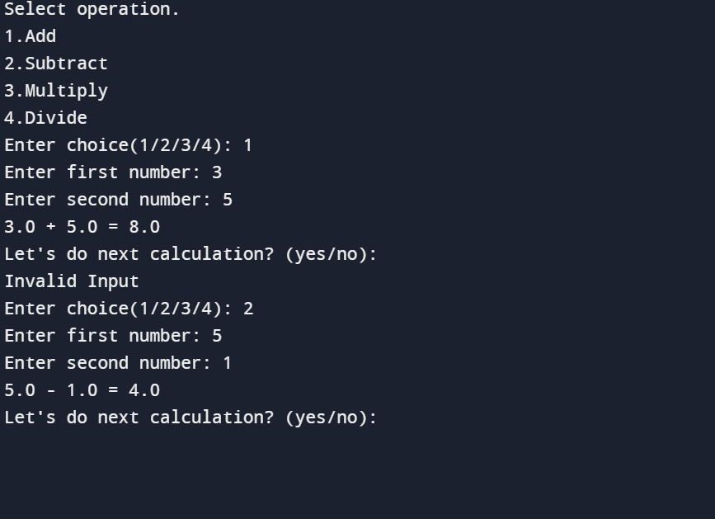

**2.Concatenate,reverse and slice a string in python?**

greeting = "Hello, World!"

#reverse the string

print(greeting[::-1])

#slice the string

print(greeting[:3])

#concatenate the string

s1="Welcome"

s2="People"

s3=s1+s2

s4=s1+" "+s2

print(s3,s4)

**OUTPUT**

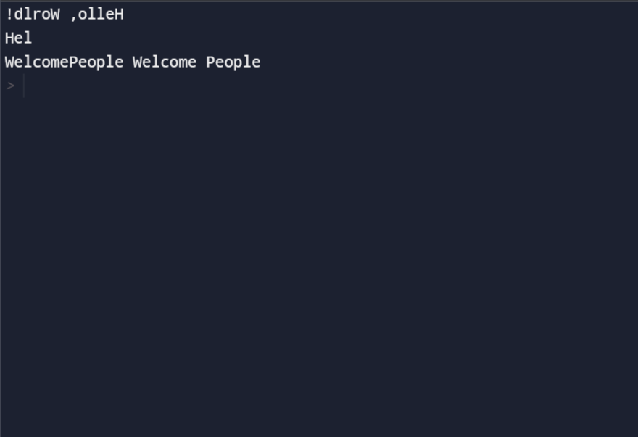

**3.Why is Python a popular programming language?**

In short, Python is a general-purpose language that is easy to learn and use. Due to its popularity, there is a big and helpful community. Also, Python is backed up by big companies like Google, Amazon, and Facebook. Python is suggested as the first programming language to learn due to its English-like syntax.

* Python is Easy to Learn and Use
* Python is Handy for Web Development Purposes
* The Language is Extensively used in Data Science
* Has Multiple Libraries and Frameworks
* Python can be used in ML tool
* Python for Academics
* Has a Highly Supportive Community
* Flexibility and Reliability
* Python Automates Tasks
* The First-choice Always

**4.What are the other frameworks that can be used with python?**

**1.**CubicWeb

2. Django

3. Giotto

4. Pylons Framework

5. Pyramid Framework

6. TurboGears

7. Web2Py

**Micro Frameworks:**

8. Bottle

9. CherryPy

10. Dash

11. Falcon

12. Flask

13. Hug

14. MorePath

### 15. Pycnic

### Asynchronous Frameworks:

### 16. AIOHTTP

### 17. Growler

### 18. Uvloop

### 19. Sanic

### 20. Tornado

**6. Full form of WSGI ?**

Web Server Gateway Interface